There are some things you can try: the 1st thing you want to do is make sure you are logged into the machine as a user who has rights to install software. Then you should try running the installer by right clicking on it and selecting “Run as Administrator”.

If the installer still fails to run you will need to do the following and let me know your results:

* 1. Open the cmd window as Administrator *(when you can search for cmd then right-click on the cmd.exe and click the "Run as administrator" option).*
  2. Navigate to the directory where you have the Helix ALM client installer saved and run the following command run the command ttclientinstall.exe -i Silent. You can check task manager and look in the "Background process" area for the silent installer processes. If the installer is able to run silently there should be a "LaunchAnywhere (32 bit)" process and likely also some type of "Java" process.
  3. If the Helix ALM client is successfully installed stop here.
  4. If the Helix ALM client did not install successfully continue with the next set of steps
  5. Rename the installer from ttwinclientinstall.exe to ttwinclientinstall.zip
  6. Extract the contents of ttwinclientinstall.zip to a directory (for future steps the directory will be called ttwininstall). The contents of the directory should be a folder called InstallerData and Windows.

NOTE: If you have problems extracting the contents try using 7-zip. You can get 7-zip from <http://www.7-zip.org/download.html>. I would recommend getting the 9.20 version and not one of the beta versions on the page (I've seen issues with the beta versions also having trouble extracting our renamed installer zip files).

* 1. Go into the ttwininstall\Windows\resource\jre folder.

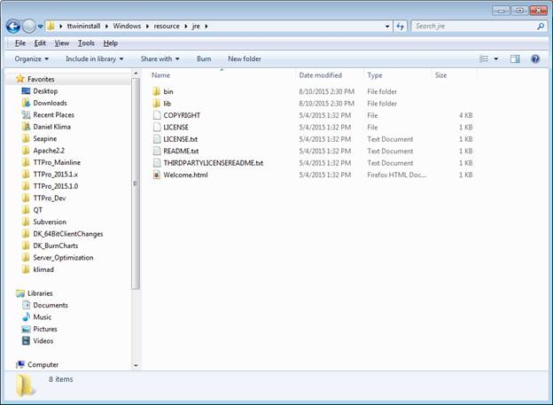

* 1. Copy the lib and bin folders

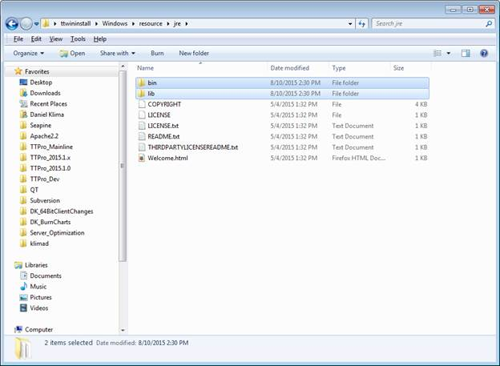

* 1. Navigate back to the ttwininstall\Windows and paste the lib and bin folders.

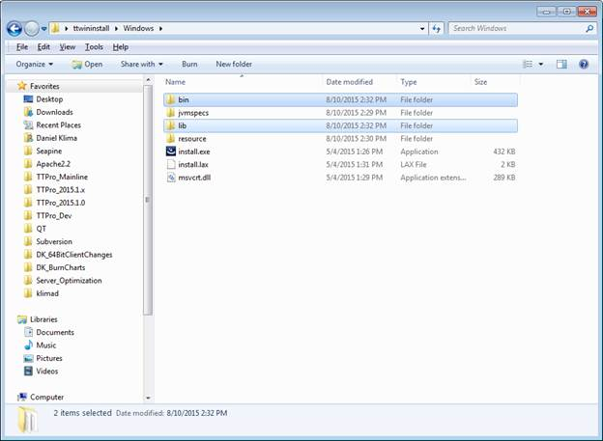

* 1. Try to run install.exe from a command prompt and see if runs or provides any errors.
  2. If the client is successfully installed stop here.

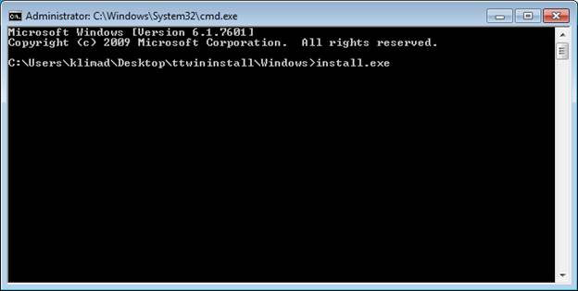

* 1. If it doesn’t work try editing a file called install.Iax in the ttwininstall\Windows folder. Open the install.Iax file with a text editor like wordpad.exe.

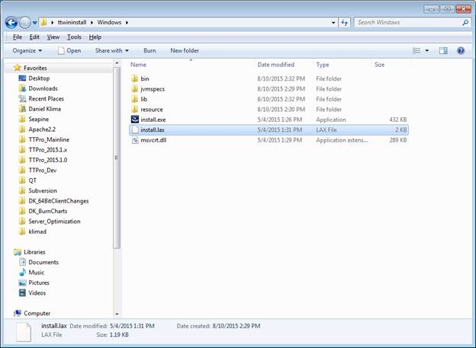

* 1. There are two strings that determine how much memory are needed to create the java jvm. these are listed below:

lax.nl.java.option.java.heap.size.initial=16777216

lax.nl.java.option.java.heap.size.max= 1073741824

* 1. Change the string so they have smaller values. In some testing I was able to get the installer to work with the following smaller values. I only changed the max size.

lax.nl.java.option.java.heap.size.initial=16777216

lax.nl.java.option.java.heap.size.max=33741824

* 1. Open a command prompt and navigate to the ttwininstall
  2. Try to run install.exe from a command prompt and see if runs or provides any errors. It should now try to use less memory. If it fails with a java memory error you can try to keep lowering the java heap memory and continue to try running the installer to see if it will work.